# COMPUTER NETWORKING LAB

Muhammad Azan Afzal

22I-1741

CY-B

Assignment number 1

## CLIENT AND SERVER SETUP:

1. **You have to implement TCP client server using socket programming in c++/c. Client will**

**take an input string from user and will send it to server. Server is going to simply receive**

**the string and display it.**

1. **Now you have to use two laptops or computers. If not available at home, then you can**

**use lab computers. Place client code at one computer and server on another computer.**

**Now your client should be able to connect server which is on another computer.**

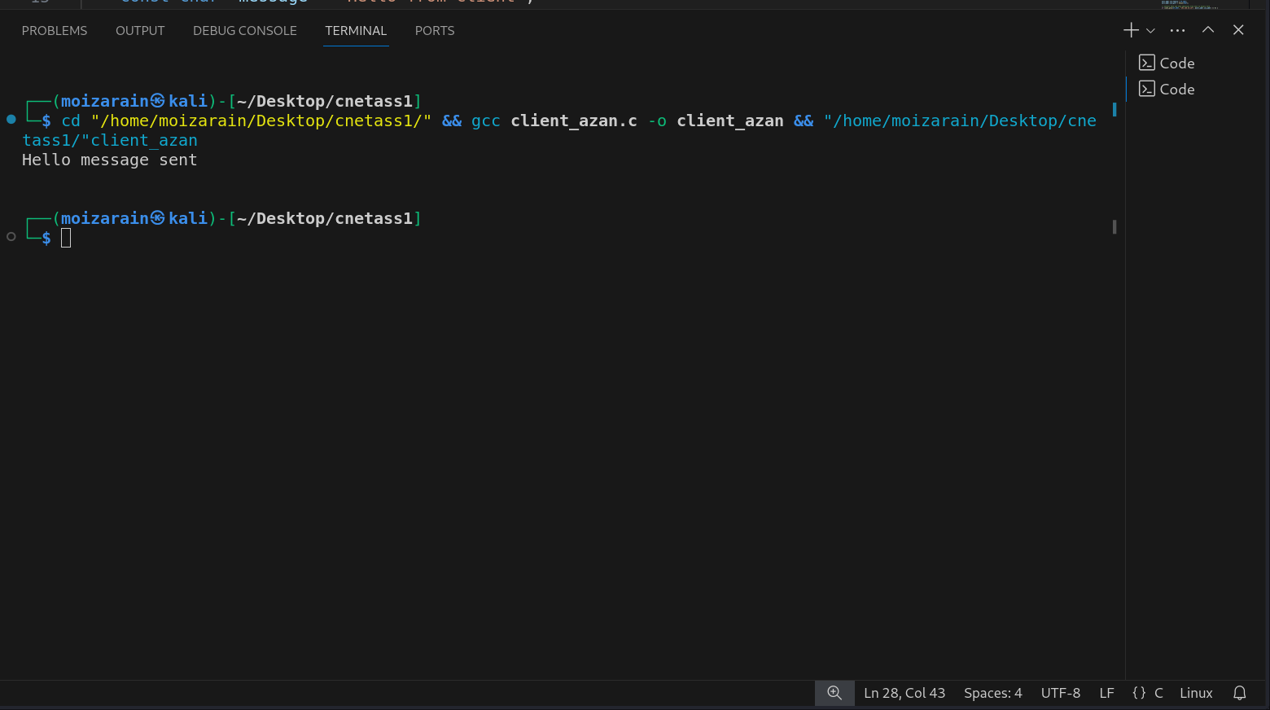

Figure 1 CLIENT SETUP

It is the setup of client in which hello message is sent from the client side.

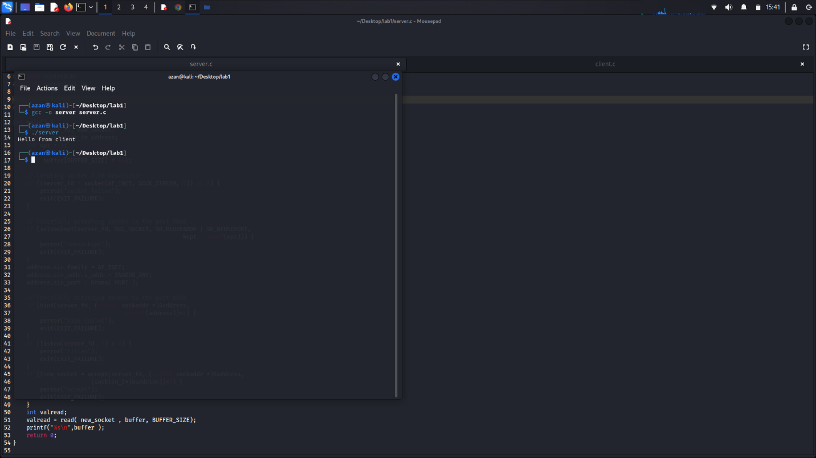

Figure 2 server side

The server setup has received hello message from client side.

For server and client setup, we add an extra library #include <arpa/inet.h> and IP of the server which was receiving message and in client that IP of server is used.

1. **Run Wireshark and capture network traffic. Remember Wireshark should be running**

**when you will perform step no 2.**

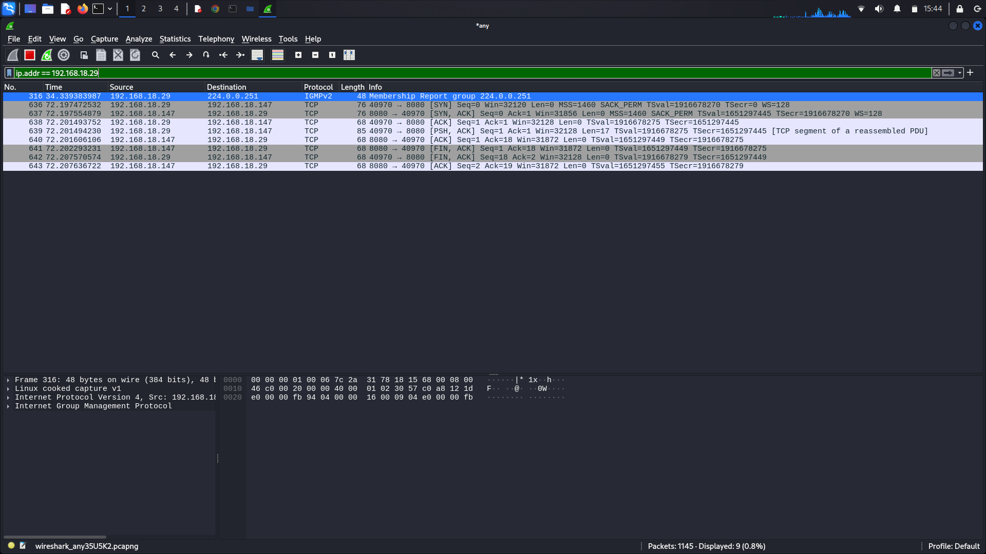

Figure 3 Wireshark setup

In this screenshot, Wireshark has been setup and is running when client send message and is received by the server.

**6. What is source IP address?**

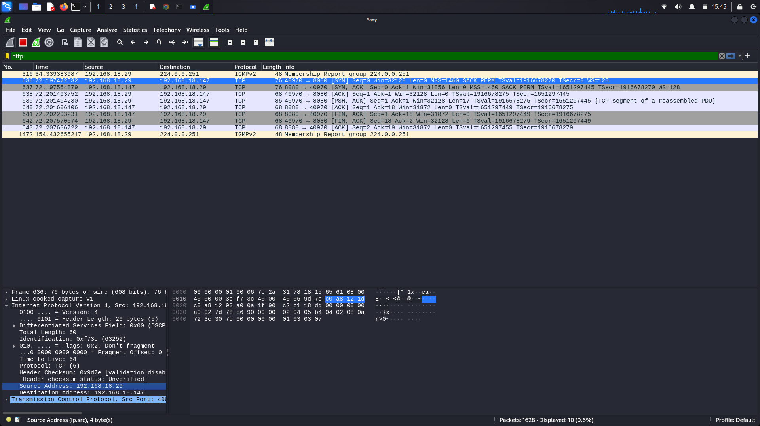

Figure 4 source IP

As you see that if we open internet protocol version side, we can see the source address which is 192.168.18.29.

**7. What is destination IP address?**

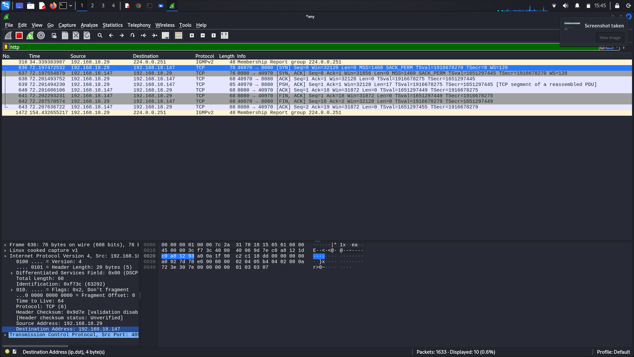

Figure 5 destination address

Same for the destination address, below source address, destination address is found which is 192.168.18.147 .

**8. Using Wireshark, find out what message was sent by client to server.**

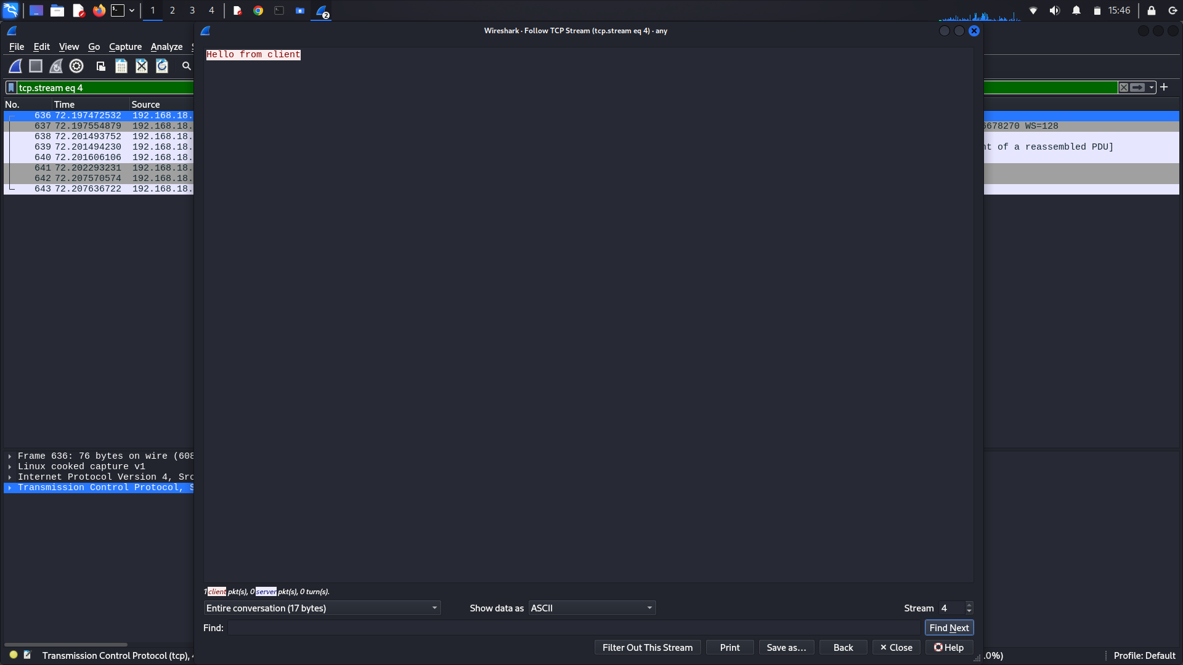

Figure 6 message sent

As you can see, hello from client was sent from client which was received be the server. It has been shown in Wireshark, in Wireshark if we open or right click any packet and go to follow option, there will be a TCP stream option, by opening it your message can be shown there which was sent.

**9. What is source port number?**

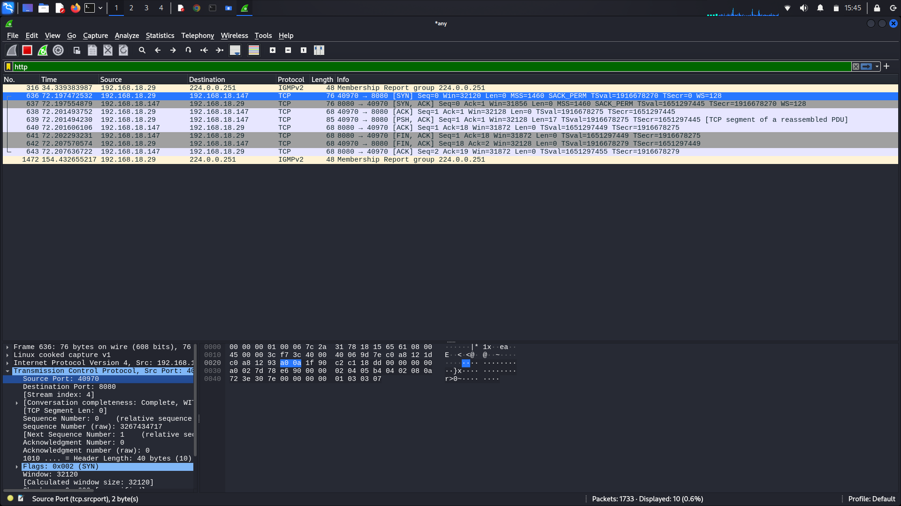

Figure 7 source port number

In this picture , source port number is shown which is 40970.

**10. What is destination port number?**

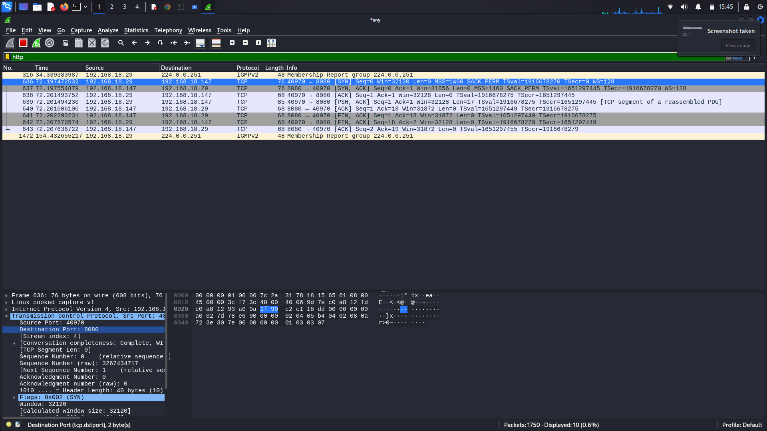

Figure 8 destination port

In this picture, destination port is been shown which is 8080.

**11. Now modify your code such that message sent by client should not be that easy to sniff**

**through Wireshark**

**12. After modifying code, show what difference you have observed in Wireshark after step**

**no 11.**

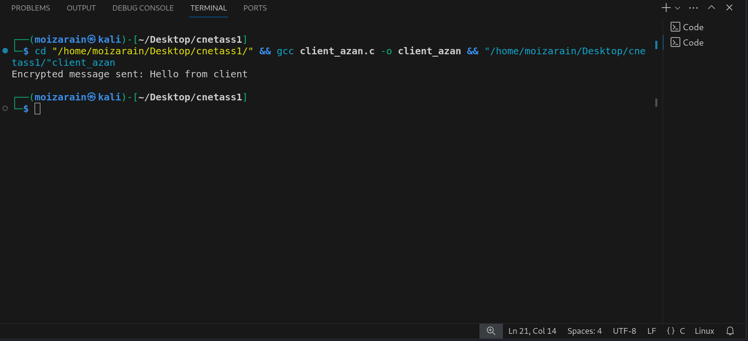

Figure 9client

In this picture, client has sent an encrypted message Hello from client.

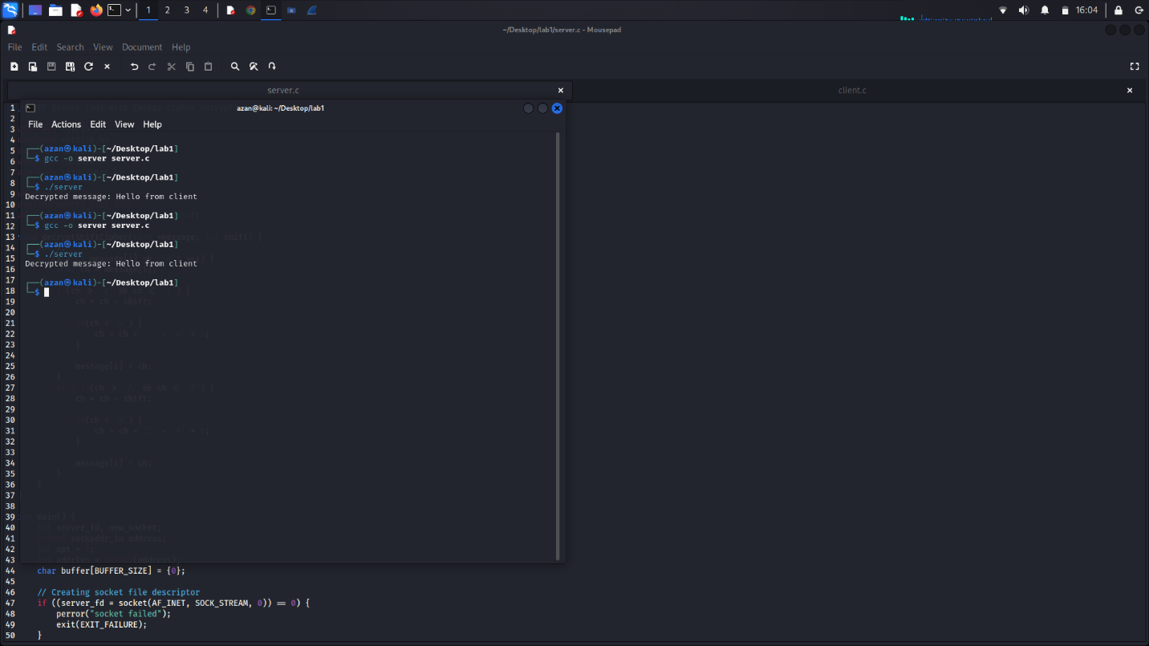

Figure 10server

In this picture, server has received the message sent by the client that is Hello from client.

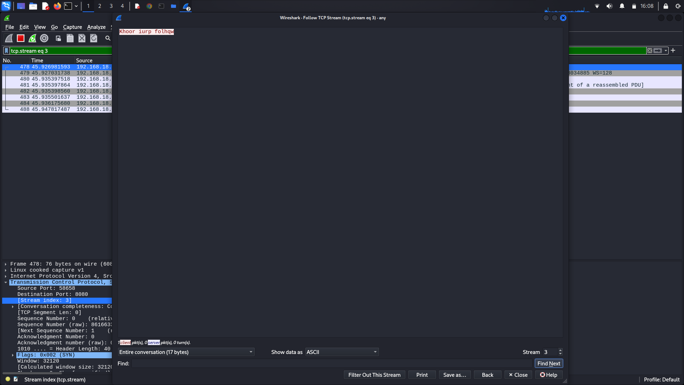

Figure 11 Encrypted message

In this picture, same as explained in question 8, if we go to TCP stream option, it is showing our encrypted message. I used Caesar cipher in it. The key in it used is 3 and character or alphabet which is used it will add 3 in the character and then check what is the alphabet in that number and then will print it. In this case, our message is Hello from client, if we look into the encrypted message that is **khoor iurp folhqw** . As you see if we add 3 in hello, the next character after adding 3 is k that is printed and same for case for every alphabet like adding 3 in e , character which comes is h and so on the process will continue until the text is finished.